

**KTH Royal Institute of Technology**

**Computer Applications for Power Systems**

**Assignment no 2**

**Name: Shahmeer Mohsin**

**Email: (**[**shahmeer@kth.se**](mailto:shahmeer@kth.se)**)**

**Program: Energy for Smart Cities**

My KNN classification algorithm allowed me to find out what power system states caused various operational states. The training data was extracted from the measurements table, whereas the test data was extracted from analog_values. The training data in the measurements table was preprocessed and a new table was made.

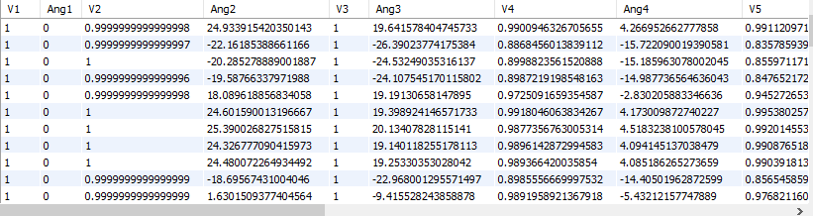

Note that this runs all the way until V9 and Ang9 depicting all the buses. On this data, kmeans clustering was applied, giving labels as shown below:

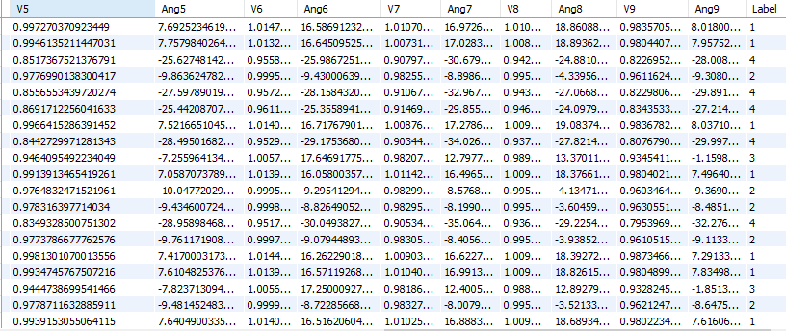

Label 1 represents low load and occurs when the voltage sum of buses 6, 7, and 8 is greater than a threshold. When this happens, these buses have a voltage greater than 1.01 pu. Whenever a low load case occurs at bus 7, it affects nearby buses i.e. bus 6 and 8. The condition is:

V6+V7+V8>3.02 pu

Label 3 represents high load and occurs when the voltage sum of buses 6, 7, and 8 (the buses connected to loads) is less than a threshold (2.93 pu). The condition is:

V5+V7+V9<2.93 pu

Label 4 represents disconnected case. It happens when the voltage at a certain bus is too low (<0.85 in our case) The condition is:

Vi<0.85

Label 3 represents the shutdown case. It happens when the power injected at the generator buses is too low (< 0.02).

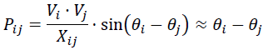

When P14, P28 or P36<0.02, we get the shut-down case.

The KNN algorithm was applied on the test samples and gave 5 labels from each class.